Event Handling

* Events

An event is an action that could be triggered as a result of the user action or system generated event. For example, a mouse click, loading of a web page, pressing a key, window resizes, and other interactions are called events.

* Event Handling

Event handling essentially allows the user to interact with a webpage and do something specific when a certain event like a click or a hover happens. When the user interacts with the application, events are fired, for example, mouseover, key press, change event, and so on. The application must handle events and execute the code. In short, events are the actions to which javascript can respond. To have a deeper understanding of [usereducer](https://www.knowledgehut.com/blog/web-development/usereducer-in-react" \t "_blank) in React, click here.

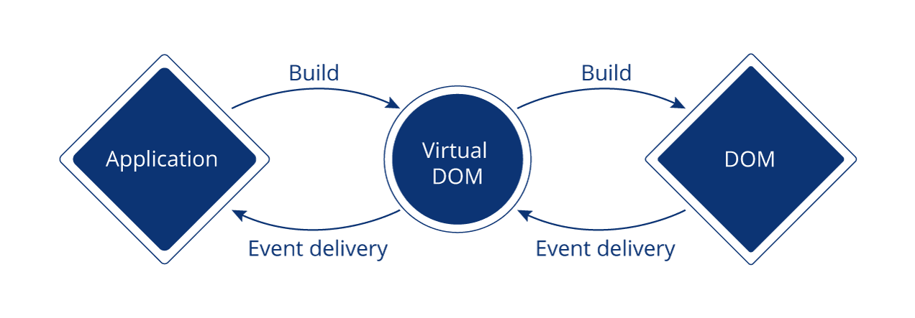

The actions to which JavaScript can respond are called events. Handling events with react is very similar to handling events in DOM elements. Below are some general events that you would see in and out when dealing with react based websites:

* Clicking an element
* Submitting a form
* Scrolling page
* Hovering an element
* Loading a webpage
* Input field change
* User stroking a key
* Image loading